**First Semester 2023-24**

**Data Structures and Algorithms Design (Merged-SEZG519/SSZG519)**

**Exercises (Non-linear Data Structures)**

1. Draw stack execution steps in non-recursive preorder, inorder, and postorder traversals of the following tree.

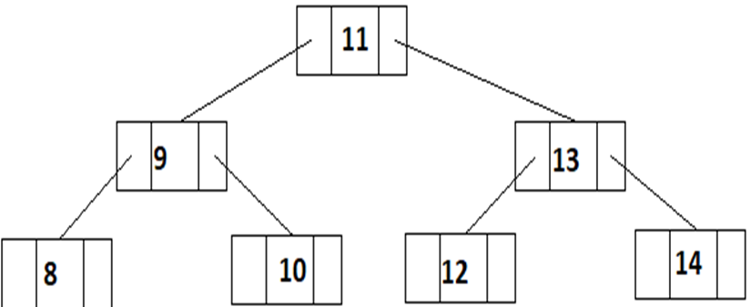

1. (A) Insert the following data in a MIN heap tree. Tree is initially empty. Depict the tree and corresponding array for each insertion.

100, 40, 50, 10, 15, 50, 40, 5, 101 (maintain the order while insertion)

(B) Depict the tree and corresponding array for deletion of root node.

1. Determine the sequence of data while insertion for Q-2 to make insert operation efficient. (Hint: Insert operation will be efficient if reheaping is not required).